Children’s Book Council of Australia - Book Week
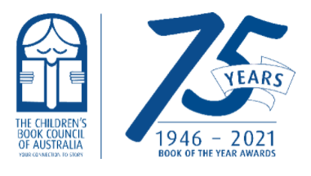
https://www.cbca.org.au/cbca-book-week

CBCA BOOK WEEK
Each year since 1945 the CBCA has brought children and books together across Australia through CBCA Book Week. During this time schools and public libraries spend one glorious week celebrating books and Australian children's authors and illustrators. Classroom teachers, teacher librarians and public librarians create colourful displays, develop activities, run competitions and tell stories relating to a theme to highlight the importance of reading. You will often see parades with students dressed as their favourite book character.
At Irrawang Public School, we host a Book Week Celebration Day, usually on the Wednesday of Book Week - 21st August-27th August.
On the day we host a costume parade where students dress up as their favourite characters or heroes from storybooks, host a Book Fair in the Library where students and families can purchase a range of books, posters and stationary and we also organise a range of Book Week activities that students can participate in throughout the day.
Book Week is a great week of fun and a perfect opportunity to celebrate the joys of reading!
Book Week 2021 – ‘Old Worlds, New Worlds, Other Worlds’
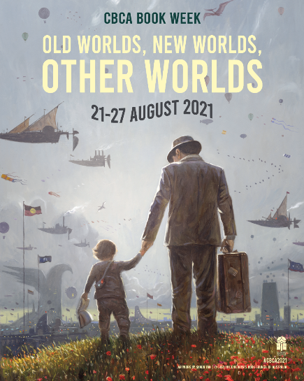
Parade Day: Wednesday 25th August
Book Fair: ONLINE
23rd August-27th August
Watch out for the link on the Irrawang Public School’s Facebook page for the link to what is available.
Activities: Class fun

Book Week 2020 – ‘Curious Creatures, Wild Minds’
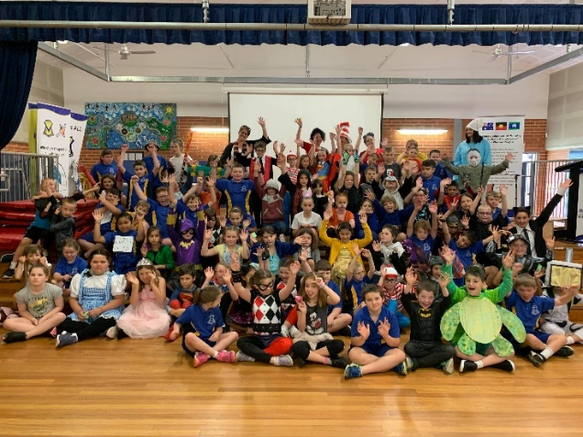
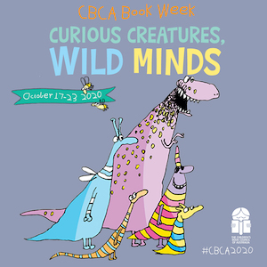
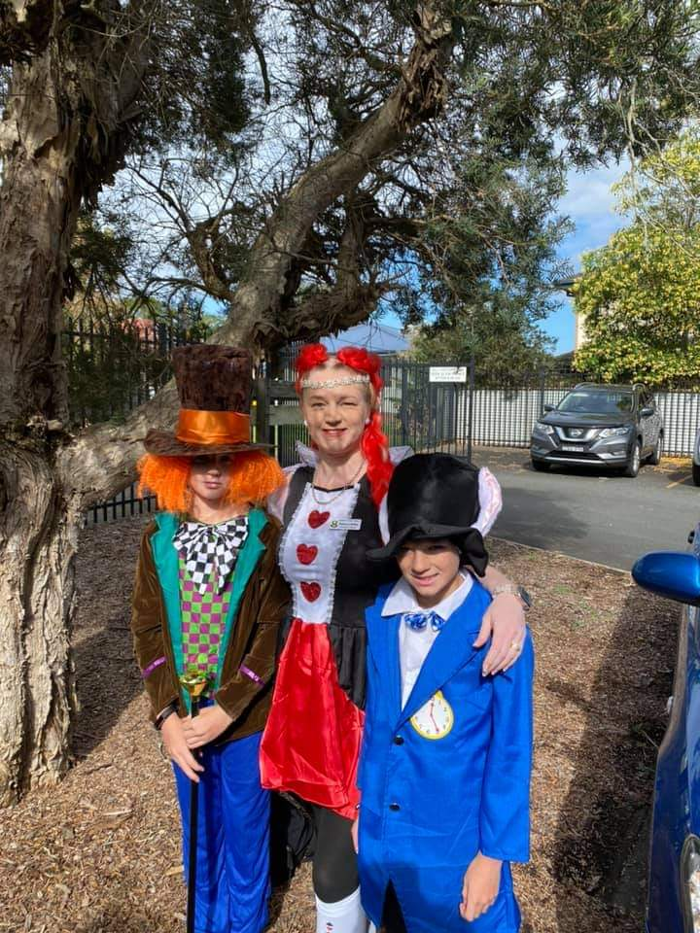
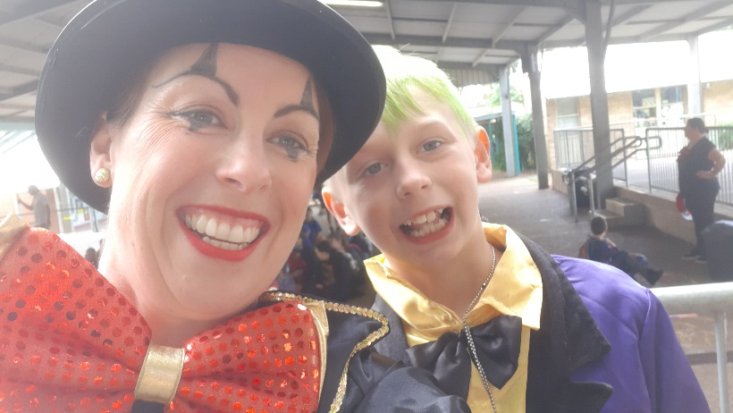
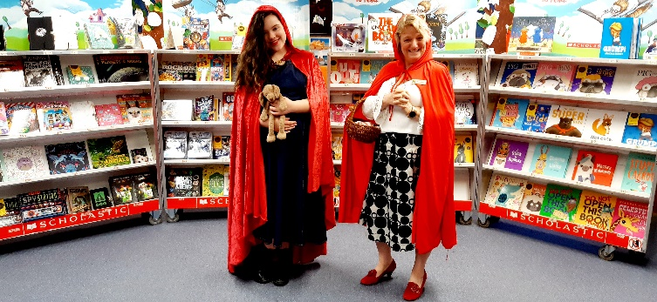

BOOK WEEK FUN
https://drive.google.com/file/d/1ltX1PWYMkDQ1LLzEz43DZDPBHeLclABn/view?usp=sharing
https://drive.google.com/file/d/19DOdYtOWRH_aonBGo3LuVzu78RNamOxX/view?usp=sharing

