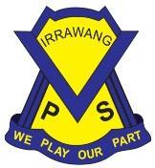
IRRAWANG PUBLIC SCHOOL PRESCHOOL

Interactions with Children Procedure
National Quality Standard Education and Care Services National Law and National Regulations | Associated department policy, procedure or guideline | Reference document(s) and/or advice from a recognised authority
NQS: 51, 5.2  Law Section: 166  Regulations: 155, 156 | Leading and operating department preschool guidelines  Code of Conduct policy  Student Welfare policy  Student Behaviour policy  Anti-Racism policy | ACECQA information sheets:  - Relationships with children [PDF 2.3 MB]  - Supporting children to regulate their own behaviour [PDF 1,018 KB]  - Inappropriate discipline [PDF 573 KB]  ACECQA’s policy and procedures guidelines – Interactions with children [PDF 201 KB]

Responsibilities
School principal | The principal as nominated supervisor, educational leader and responsible person holds primary responsibility for the preschool.  The principal is responsible for ensuring:  - the preschool is compliant with legislative standards related to this procedure at all times  - all staff involved in the preschool are familiar with and implement this procedure  - all procedures are current and reviewed as part of a continuous cycle of self- assessment.  These tasks may be delegated to other members of the preschool team, but the responsibility sits with the principal.
Preschool supervisor | The preschool supervisor supports the principal in their role and is responsible for leading the review of this procedure through a process of self-assessment and critical reflection. This could include:  - analysing complaints, incidents or issues and the implications for updates to this procedure  - reflecting on how this procedure is informed by stakeholder feedback and relevant expert authorities  - planning and discussing ways to engage with families and communities, including how changes are communicated  - developing strategies to induct all staff when procedures are updated to ensure practice is embedded.
Preschool teacher(s) and educator(s) | Preschool teachers and educators are responsible for working with the preschool leadership team to ensure:  - all staff in the preschool and daily practices comply with this procedure  - this procedure is stored in a way that it is accessible to all staff, families, visitors and volunteers  - they are actively involved in the review of this procedure, as required, or at least annually  - details of this procedure’s review are documented.

Procedure
Introduction | No preschool child will be subjected to any form of corporal punishment or discipline that is unreasonable in the circumstances.  All teachers, educators, visitors and volunteers will:  - maintain the dignity and rights of each child when interacting with them through being committed to inclusive practices, acknowledging children’s feelings, asking permission before taking their photo and embedding a culture of respect and dignity within the preschool.  - support each child to develop warm, trusting, respectful relationships with other children and with adults by positively guiding children and actively listening and responding to children’s ideas and feelings. Celebrating moments when children have achieved something. Modelling acceptable behaviour by proactively encouraging children to negotiate, make decisions, collaborate and share during their play and by being truthful and honest with children at all times.  - encourage each child to express themselves and their opinions, engaging them in sustained conversations about things that interest them and being proactive in developing children’s sense of agency and self-regulation by listening carefully to children’s feelings and concerns, following up on children’s idea’s for learning and discussing issues of inclusion, exclusion, and unfair behaviour.  - respond to each child’s strengths, abilities, interests and play, to support curriculum decision making through focusing on the strengths that children bring to the preschool, building on abilities over time, extending on interests shared in groups, promoting autonomy, self-reliance and self-esteem through giving children choice, responsibility and access to resources to support their play and strengthen their holistic growth.
The preschool program | All educators, visitors and volunteers will create engaging and effective classrooms, and inclusive and safe school communities for all NSW public school preschool children. Children and staff have the right and responsibility to engage in positive and respectful relationships based on valuing the interests, abilities and diversity of others. All children and staff have the right to be treated fairly and with dignity in an environment free from intimidation, harassment, victimisation, discrimination and continued disruption. Student Behaviour.  The Preschool Program will:  - provide regular opportunities for children to engage in meaningful play experiences that promote positive interactions and build relationships. This is done by:  - Responding to children’s spontaneous interests and ensuring materials/experiences are provided promptly to extend on their interests and strengthen their skills and understanding.  - Supporting each child to develop warm, trusting, respectful relationships with other children and with adults ensuring they model what is expected of the children, including being truthful, honest and empathetic.  - Providing children with options and choices throughout the day, and the opportunity to live in the now, practice decision making and problem solving, and confidently learn and explore their world through periods of uninterrupted free play.  - Listening to children’s conversations and use these as opportunities to provide experiences that will build on children’s strengths, strengthen their abilities and further support curriculum decision making.  - supporting cooperative play through the provision of provocations, promoting leadership in child-led activities.  - Ensuring there is a balance of play experiences catering for independent and group exploration.  - provide support and guidance for every child to respect individual differences and regard for each family’s cultural values. This is achieved by:  - Showing understanding, respect and value towards family backgrounds and culture through immersing cultural perspectives into play and learning experiences  - celebrating individual differences through play and exploration of artefacts and other resources that value cultural heritage  - inclusion of resources that include people of diverse ability, culture and orientation  - acknowledgement and engagement with a variety of cultural celebrations  - support children to manage their own behaviour and to develop self-regulation. This is achieved by:  - incorporating whole school strategies consistent with Positive Behaviour for Learning (PBL) expectations.  - creating and promoting PBL matrixes for our preschool environments, allowing staff and children to discuss what Safety, Responsibility, Respect and Learning looks like at preschool.  - utilising whole school strategies such as ‘Aussie 5’ to scaffold and assist children in identifying appropriate choices when participating in play and learning experiences.  - consistently using positive language to encourage children to consider how their choices and decisions impact on others and what we can do to ensure everybody is ‘Safe and Happy at Preschool’.  - Giving verbal, visual and/or physical prompts/cues to help children make positive choices and prompting and praising expected behaviours in a positive and gentle way.  - using the strategy of ‘time with’ a child who is experiencing a temporary loss of control to move to effective self-regulation. Educators encourage the children to take some time to identify how they feel by identifying and or naming the corresponding emotion and talking with educator about how they are feeling. Educators model, support and encourage deep breathing with the child to also assist in self-regulation.  - providing children with strategies from ‘The Zones of Regulation’ to identify with and make informed choices about their behaviour, feelings and emotions. Preschool children will learn about the 4 zones (blue, green, yellow and red) and how to use strategies or tools to stay in a zone or move from one to another. Each zone is represented with a character that children can refer to when self-regulating their emotions.  - staff prompting and redirecting children using the ‘Show me 5’ prompts – I am calm / my eyes are on the speaker / My ears are listening / My voice is off / My hands are to myself, to also support making positive choices.  - supporting and promoting positive and respectful student behaviour, in line with effective practice and evidence-informed positive behaviour support approach, across the care continuum and adopt components from the IPS Care Continuum appropriate for any IPS Preschool child.  - Being familiar with and employing components of any Personalised Risk Management Plans, Behaviour Support and/or Response Plans associated with children who may be of Risk of Harm to themselves or to others. Also, seeking the support of an executive member if a significant incident occurs in order to manage and maintain adequate supervision.  - Refer to and implement where necessary, components from relevant policies for DoE Preschools such as WHS, Wellbeing Framework for schools, Disability Standards for Education and Complaints Procedure.
Implementing the child safe standards – Responding to a disclosure of abuse | If a child discloses abuse to a staff member, they will respond appropriately and in a supportive manner. The Department of Communities and Justice provides this advice:  - respond to a disclosure by being calm and listening carefully and non-judgmentally  - let the child tell their story freely and in their own way  - acknowledge how difficult it may have been to disclose and reassure the child that it was the right thing to do  - do not interview or gather evidence, as this is the responsibility of specially trained caseworkers and police officers  - immediately after the disclosure write down and date the comments and statements made by the child using their exact words  - record any observations about the child’s mood or demeanour  - report this information to the principal.

Record of procedure’s review
Date of review and Who was involved | 17/3/21  Michelle Lynch (Pedagogical Leader)  Alexandra Hay (SLSO)  26/5/22  Michelle Lynch (Pedagogical Leader)  13/6/22  Michelle Lynch (Pedagogical Leader)  28/6/22  Michelle Lynch (Pedagogical Leader)  Hylie McEvoy (Preschool Educator)  30/5/23  Michelle Lynch (Pedagogical Leader)  Sarah Rudolph (Assistant Principal)  15/10/23  Michelle Lynch (Pedagogical Leader)  Hylie McEvoy (Preschool Educator)
Key changes made and reason why | 13/6/22  Updates in response to parental/staff/community feedback  28/6/22  Changes made to reflect updated programs implemented in Preschool.  30/5/23  Link added to DoE Policy Statement regarding student behaviour.  Addition of Care Continuum.  Addition of staff awareness of following documents, policies and procedures to adapt/modify to manage children in Preschool (WHS, Wellbeing Framework for schools, Disability Standards for Education and Complaints Procedure).  Addition of staff responsibility to be aware of and employ Personalised Risk Management Plans where/when necessary.  Addition of support of exec member if required due to significant incident/accident/illness/trauma.  Removal of Resources and events  Update with current procedures to be used in whole school P-6 setting.  Added Code of Conduct and Mandatory Reporting.  7/10/2023  Updated (additions/deletions) as per Early Learning Leading and Operating Preschool Guidelines vOct2023
Record of communication of significant changes to relevant stakeholders | Principal: Email & Acknowledgement Spreadsheet 16/10/23  Staff: Email & Acknowledgement Spreadsheet 16/10/23  Parents: Sentral Parent Portal 16/10/23  Please note, parents must be notified at least 14 days prior to a change that may have a significant impact on their service’s provision of education and care or a family’s ability to use the service.

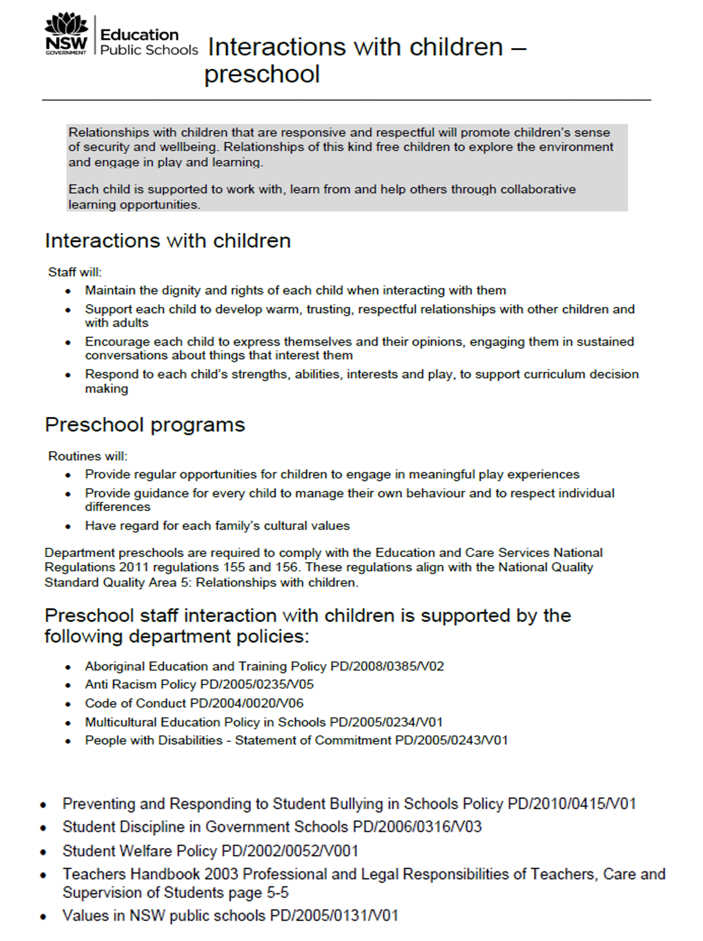

Aussie 5

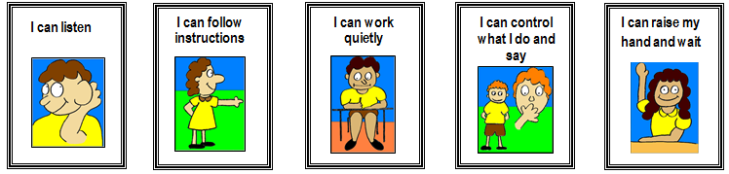

The ZONES of Regulation

