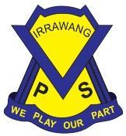
IRRAWANG PUBLIC SCHOOL PRESCHOOL

Preschool Programming for Planning and Assessing Procedure
Associated National Quality Standards | Education and Care Services National Law or Regulation | Associated department policy, procedure or guideline
1.1.1 - Approved Learning Framework | Section 323 (Repealed)  Regulation 73  Regulation 74  Regulation 75  Regulation 76  Regulation 168(2)(h)  Regulation 254 | Leading and operating department preschool guidelines
Pre-reading and reference documents
Staff roles and responsibilities
School principal | The principal as Nominated Supervisor, Educational Leader and Responsible Person holds primary responsibility for the preschool.  The principal is responsible for ensuring:  - the preschool is compliant with legislative standards related to this procedure at all times  - all staff involved in the preschool are familiar with and implement this procedure  - all procedures are current and reviewed as part of a continuous cycle of self- assessment.
Preschool supervisor | The preschool supervisor supports the principal in their role and is responsible for leading the review of this procedure through a process of self-assessment and critical reflection. This could include:  - analysing complaints, incidents or issues and what the implications are for the updates to this procedure  - reflecting on how this procedure is informed by relevant recognised authorities  - planning and discussing ways to engage with families and communities, including how changes are communicated  - developing strategies to induct all staff when procedures are updated to ensure practice is embedded.
Preschool educators  (This includes all staff; casuals, lunch cover, volunteers and anyone else who works in the preschool) | The preschool educators are responsible for working with leadership to ensure:  - all staff in the preschool and daily practices comply with this procedure  - storing this procedure in the preschool, and making it accessible to all staff, families, visitors and volunteers  - being actively involved in the review of this procedure, as required, or at least annually  - ensuring the details of this procedure’s review are documented.
Procedure
At Irrawang Public School Preschool, educators:

- Construct a personal and Preschool Philosophy underpinning the preschool’s vision & informing programming for planning and assessing.
- Utilise The Early Years Learning Framework (EYLF V1&V2) to guide the development of the educational program and ensure it supports each child’s learning and development outcomes.
- Use the Early Years Planning Cycle: Belonging, Being & Becoming incorporating regular observations to guide and support the designing of quality learning experiences that meet the needs, strengths, interests and goals of all children.

Question (observe & collect information, analyse learning):
- Children are actively engaged in the core curriculum and learning experiences. They are encouraged to make choices, request resources and are given time to revisit, repeat, consolidate, master and extend their learning.
- Educators identify individual and group strengths, interests and goals from:
~ initial enrolment interview with families
~ jottings of daily interactions about children’s learning, engagement, conversations and interests
~ jottings about children’s engagement in the programmed experiences
~ formal observations of children in focus
~ maintaining connections with families (phone calls, Preschool closed Facebook page, inbox messages, interviews).
- Educators clarify specific objectives, analyse learning, the learning environment, role of educator and assessment/evaluation methods and evidence through:
~ consultative discussions and collaborative decision-making with the Preschool Team, Pedagogical Leader, Preschool Advisor and other EC educators to drive programming and planning.

Plan (child observation):
- Design learning experiences from:
~ documentation of children’s needs from previous conversations with families via phone, Facebook or face to face.
~ goal setting with/for children
~ adult and child initiatives
~ reflections from intentional teaching & scaffolds
- Children are closely observed by educators (where they are at/what they are working towards). The Transition to School Statements are closely referred to track/refer to children’s attainment of EYLF Outcomes.
- Educators have focus children each week, however, will record information when engaging with all children and pass on information when required.
- Families are encouraged to add input to the daily program on the program on display daily in the foyer.
- Educators have conversations with families and record information in the children’s Communication Book.
- Educators refer to the Early Years Learning Framework (V1&V2) to analyse the development of each child.

Act/Do (implementation):
- Educators implement learning experiences with play provocations into the core curriculum through:
~ setting up active learning environments daily based on planning decisions,
~ developing relationships with children and families,
~ monitoring and documenting learning and pedagogical practices daily on checklists, whiteboards, learning stories and children’s personal observations.
- Educators engage children in project work through provocations and intentional teaching.
- Educators plan appropriate learning experiences for a child or children to engage in. They may set up a provocation, explicitly teach (intentional teaching) a child through a planned experiences and collect documentation for a child’s Learning Journey (learning story, observations, photos, parent feedback, letters and other work samples).

Reflect/Review (Assessment):
- Assessments can occur at any time during these phases.
- Educators will assess and evaluate teaching and learning through:
~ planned child observations,
~ learning stories that may include samples of a child’s work, photos or speech,
~ daily informal debrief discussions with Preschool Team,
~ weekly staff meetings with specific outcome/principal/practice focus,
~ formal surveys capturing family’s responses to context/content,
~ regular engagement in critical reflection to inform/inspire/adjust personal/site Philosophy.
- Child observations will be recorded using photos and videos and posted onto the private Preschool Facebook Page. These observations are recorded in a document on the Preschool Google Drive to monitor the planning cycle of learning for each child.

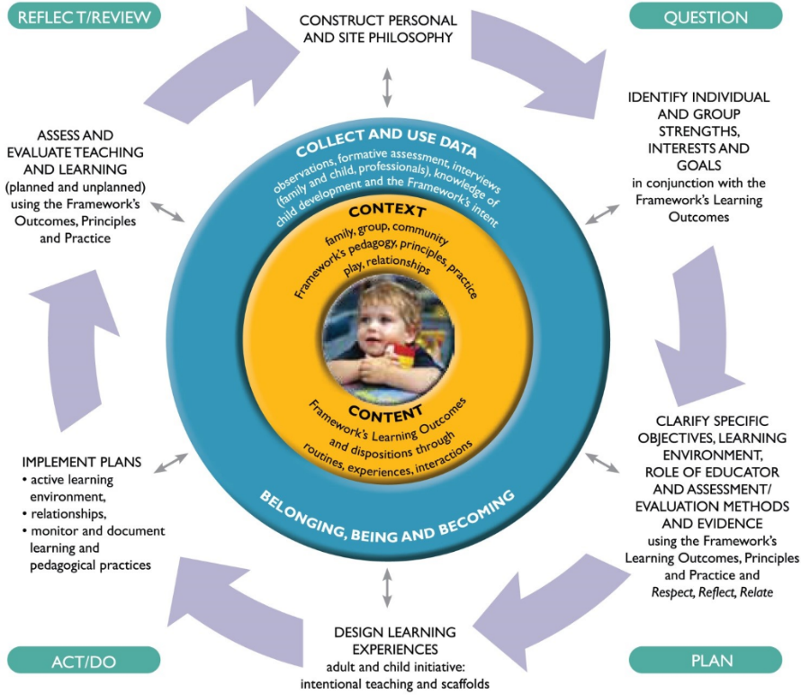

Observation Cycle
Our Preschool operates for 40 weeks each year with most children attending a 5 day fortnight. Our hours of operation are from 8.55am till 2.55pm. Educators will follow the observation and planning cycle beginning in Term 1 and conduct 1 observation (allowing time in the first 4 weeks of Term 1 for educators to support children, build relationships and get to know them at the beginning of each year). In Terms 2-3, children will progress through 2 cycles and 1 cycle in the last term minimum.
Educators will monitor children who have moved through the observation cycle on an Observation Tracking Sheet (in the program). They will ensure that children are not overlooked and that learning objectives are monitored using their Transition to School Statements.
Over the Preschool year, there will be 6 cycles/child (minimum) with intentional teaching and learning objectives planned for them. Learning objectives will be planned for with reference to the EYLF. This structure allows for flexibility to document for other learning including on-going projects, whole class events / experiences, developmental milestones or other spontaneous learning experiences. At times, discussion with family members will occur, based on educators’ observations, prior to planning for the individual child to structure personalised objectives for the child.
Evaluation of the learning objective will be documented via educators’ observations of the child’s engagement using Microsoft Word as a collection medium (then printed and added to the child’s Learning Journey Scrapbook) with the planned play provocations/provisions. The subsequent evaluation/follow up will be recorded on the Daily Program. Educators will then evaluate and reflect on what worked well and where improvements can be made, to ensure each child’s learning experience and opportunities were effective.
Educational Program
A Sun/Rainbow Program template is used to plan for children’s interests as individuals and as groups. The Early Years Learning Framework is used as the basis for planning and each outcome is documented on the program template. Educators refer to observations, family input and other activities which may occur within the whole school to help drive the educational programming. The Glow & Grow reflection scrapbook is also used as a daily tool to record the children’s interests as input into the program.
Each week the following opportunities are offered and reflected on:
~ Parent input and family contribution,
~ Provocations set up inside and outside based on interests,
~ Whole group intentional teaching (literacy, numeracy, song, dance),
~ Planned experiences and intentional teaching,
~ Documented spontaneous experiences children were involved in throughout the day,
~ Provisions to extend on children’s interests (based on observations),
~ Health and wellbeing (fundamental movement skills, interests, health topics, games, obstacle course focus and fine motor skill practise),
~ Changes to routine or special events (preschool, whole school and community events),
~ Future planning based on observations and conversations between educators and children (educators discuss their ideas and add them to the program),
~ Evaluation and reflection on the program.
Daily Routine
Irrawang Public School Preschool have developed a daily routine to ensure children have equal time inside and outside for uninterrupted play. Educators engage with children and support them in their play, being mindful to balance supporting children with observation.
Our daily routines are flexible, and the educators are aware of the children’s needs. For example, if children are engaged in an activity and are cooperating with each other during play, we wait until there is a pause in the play, before we ask the children to pack away.
We are spontaneous in our approach to children’s play and flexible with the program based on their interests and participation. If children appear uninterested, we change provocations and programming accordingly. This is recorded on the program reflections.
Throughout the week, educators upload photos, learning stories and/or observations, including messages for all parents to view on the private Preschool Facebook Page.

Record of procedure’s review
Date of review and who was involved
11/1/21
Michelle Lynch (Pedagogical Leader)
Hylie McEvoy (Preschool Educator)
15/9/21
Hylie McEvoy (Preschool Educator)
Alexandra Hay (SLSO)
9/12/22
Hylie McEvoy (Preschool Educator)
Michelle Lynch (Pedagogical Leader)
3/3/23
Hylie McEvoy (Preschool Educator)
Alex Hay (Preschool SLSO)
Michelle Lynch (Pedagogical Leader)
Key changes made and reason/s why
15/9/21- Learning from Home COVID Restriction Procedure
9/12/22- Refining of Observation Cycle process, Removal of Learning from Home Procedure.
3/3/23-
Removed: -Observations are tracked in a document on the Preschool Google Drive which is monitored and updated by ALL staff regularly.
-An individual observation tracking sheet is begun when planning for individual children.
Addition: The Transition to School Statements are closely referred to track/refer to children’s attainment of EYLF Outcomes.
Removed: Family Jottings Book and replaced with children’s Communication Book.
Changed: 1 observation during term 1 and during Terms 2-3 there will be 2 cycles and 1 cycle in Term 4 minimum.
Changed: monitored using their Transition to School Statements.
Changed: 6 cycles/child (minimum) with intentional teaching and learning objectives planned for them.
Record of communication of significant changes to relevant stakeholders
9/12/22- Staff Email, Preschool Facebook Page, School Website

