Our Library Management System – Oliver

All students have access to our Library Management System - Oliver.
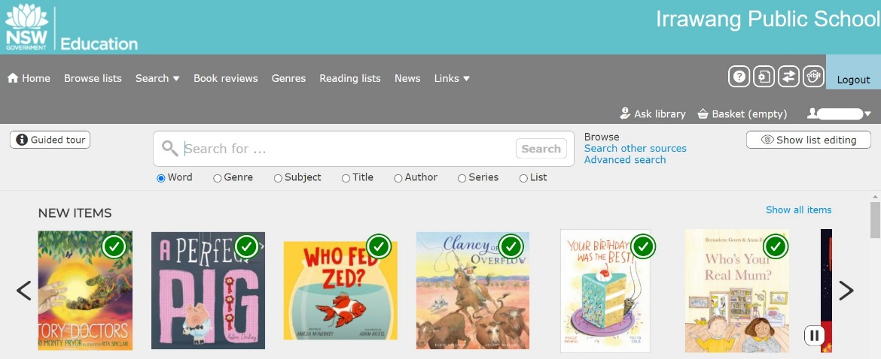
Students have been taught how to navigate to Orbit – the Student Library Platform.
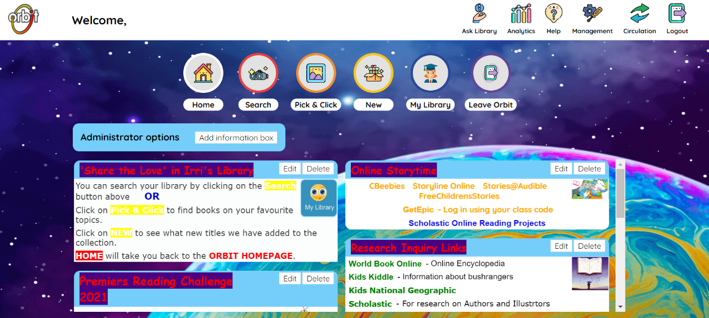
All you need to do is log in through your Student Portal using your school username and password.
How To Guide
https://docs.google.com/document/d/1ZXNGn5Rog8OtvL8qzj7Ye1saLJ_Lfe025egj4skcaR0/edit?usp=sharing

