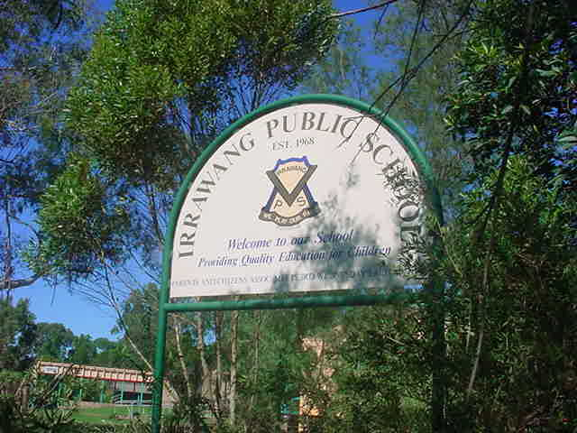
IRRAWANG PUBLIC SCHOOL

Policy for Enrolment of Students in NSW Government Schools: A Summary and Consolidation of Policy

Last Review: February, 2019 Next Review: Term 4, 2019
Principal: Mrs Stacy Mathieson

Objectives - Policy statement
General Principals are in accordance with the NSW Department of Education and Communities (DEC) policy Enrolment of Students in Government Schools - 1997.
- Children are entitled to be enrolled at the government school that is designated for the intake area within which the child’s home is situated and that the child is eligible to attend. These enrolments are called local enrolments.
- Parents may seek to enrol their child in the school of their choice.
- Schools set enrolment number to cater for local demand.
- Only accept non-local on basis of staff and permanent accommodation.
- No person will be discriminated against in enrolment on the grounds of their sex, age, race, religion, ethnicity, disability or sexual preference.
- School local areas are determined by the Department of Education through a process involving consultation between relevant parties
Enrolment Ceiling and Buffer (Start of Year)
The enrolment ceiling at the beginning of the school year will be based on 15 permanent classrooms with a buffer to accommodate local enrolments arriving through the year.
Therefore, our enrolment ceiling at the beginning of the year is 392.
The enrolment buffer at the beginning of the year is 30, calculated on 2 vacancies held to accommodate local enrolments multiplied by the 15 permanent classrooms.
Therefore, at the beginning of the year, once enrolments reach 362, enrolment cannot be offered to non-local students.
Enrolment Ceiling and Buffer (after census date)
After the school has submitted numbers to the Department (in line with census date guidelines), the number of permanent classes established will determine the enrolment ceiling. A buffer of two students per class established will remain in place, held to accommodate local enrolments throughout the year.
Enrolment Ceiling and Buffer (after census 2019)
Our school has 13 established mainstream classes K-6.
Therefore, our enrolment ceiling is 332.
The enrolment buffer is 26.
Therefore, once enrolments reach 306, enrolment during the year cannot be offered to non-local students.

In addition we have 3 classes for special placement and an on-site preschool. Enrolments for these classes are managed through a centralised panel for special education classes and through the front office, to a maximum of 40 students, for the preschool.

SPECIAL NOTE
Application for enrolment may be declined if placement generates demand for extra staff or creates disruption to school routine and organisation.
Siblings of students who move out of the school’s intake area are not guaranteed an enrolment at Irrawang public School.

Placement Panels
Where demand for non-local places exceeds availability the school will establish a placement panel to consider all non-local enrolment applications. The panel will comprise the Principal (or nominee), a staff representative and a school community member (nominated by the School Council).

Criteria for consideration for Non-Local Enrolment Applications
- Siblings already enrolled at the school.
- Special Interests / Abilities - Children wishing to access special programs e.g. Band, Music, Choir, Aerobics. Placement is dependent upon vacancies and student aptitude.
- Safety and Supervision of the student.
- Proximity and Access to the School - Where parents work in the area and/or the local school is not a viable alternative.
- Medical Reasons
- Compassionate Circumstances - After reports from the Principal, School Counsellor and welfare committees of the school in which the child is presently enrolled have been received and assessed and current issues have been resolved.
- Structure and organisation of the school - Students who wish to access defined philosophies and policies which differ from their local school.

Proof of Residence
The principals can seek any information they consider to be of assistance in determining address. Such evidence may include council rate notices, accounts for electricity, gas, water or telephone bills, lease documents or electoral enrolment confirmation.

If a person claims they are living with someone with no formal lease arrangements the principal can ask for a statutory declaration from them and/or the landlord.

Proof of Age and Name
While a birth certificate is the primary document that establishes a child's date of birth, there is no legal requirement for the schools to rely on a birth certificate for this purpose.

If a birth certificate is not available, the principal can rely on a range of secondary documents such as a passport, a NSW Ministry of Health Personal Health Record or “Blue Book”, a hospital birth card, baptism, christening, name giving or similar records.
Students under the age of 18 must be enrolled in and be known by the name which appears on their birth certificate.

Processing Enrolment Applications
The receipt of an Application for Enrolment does not necessarily lead to an immediate enrolment and attendance at school. In order to facilitate the smooth transition of a new student the principal will seek information from the student’s previous school. Where this process is likely to take more than 2 weeks the parents should be advised in writing indicating when it is likely that the enrolment will be completed.

Special Needs
Where a student with special needs applies for enrolment a full assessment of the student’s needs will be required to identify the support required to effectively meet the child’s needs.

Feedback
Parents will be provided with an explanation of the decision of the placement panel. The panel will consist of the principal, at least one other staff member and one school community member nominated by the school’s P&C. The panel will be chaired by the Principal who will have the casting vote.

Waiting Lists
Waiting lists may be established for non-local students. Parents should be advised if their child is to be placed on a waiting list. Waiting lists are current for one year.

Appeals
Where a parent wishes to appeal against the decision of the placement panel, the appeal should be made in writing to the Principal. If the matter is not resolved at the local level the Director, Educational Leadership will consider the appeal and make a determination.

School Finder for area map: https://education.nsw.gov.au/school-finder/index
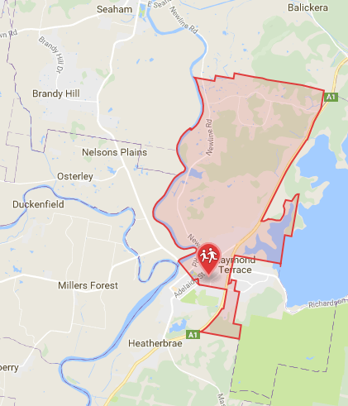Zone Map AS AT 4/7/18

Stacy Mathieson
Principal
Irrawang Public School
8th February 2019

