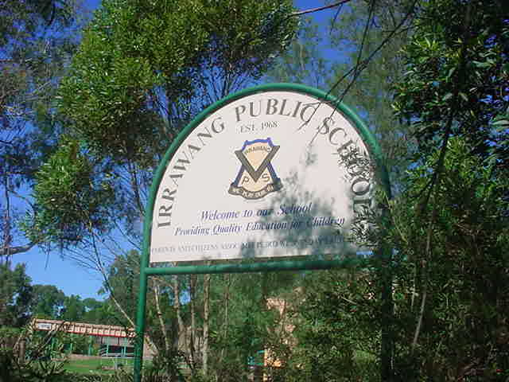

IRRAWANG PUBLIC SCHOOL

Quality Teaching and Learning

Last Review: Term 1, 2023 Next Review: Term 1, 2024
Principal: Mrs Stacy Mathieson

Rationale: At Irrawang Public School, we believe that teaching practices substantially affect the ways students approach their learning and the quality of that learning. Providing opportunities for our staff to collaboratively reflect on practice results in student improvements in learning.
Because learning and teaching are complex, multifaceted and highly interconnected activities, the principles provide a structure to help teachers find a focus for their professional learning.
(Reference: Principals of Learning and Teaching P-12 Background Paper – Blueprint for Government Schools)
Understandings: Our beliefs regarding Teaching and Learning are:
The learning environment is supportive and productive.
Building positive relationships with students, teacher and parents.
By taking appropriate responsibility for their own learning students are prepared to pursue and try out new ideas.
Students’ individual differences are acknowledged and valued.
Appropriate support is given to students to improve their learning. The learning environment promotes independence, interdependence and self motivation.
When students are encouraged to take responsibility they are involved in decision making in relation to what and how they learn.
The development of personal and interpersonal skills enhances students’ abilities to work and learn collaboratively.
A stimulating, supportive environment is conducive to students maximizing opportunities to pursue and develop their own interests and abilities.
Building diversity in teaching strategies offers wider opportunities for individual differences (e.g. abilities, learning styles and previous experiences).
Students are given opportunities to learn and apply this learning to a variety of contemporary technologies. Students’ needs, backgrounds, perspectives and interests are reflected in the learning program. The learning environment is inclusive and provides teaching strategies to accommodate the range of abilities and interests in a group and support different ways of thinking and learning. Students are challenged and supported to develop levels of thinking and application.
Students are challenged to explore, discuss, question and engage with significant ideas and practices so that they go beyond basic understandings to develop higher order, flexible thinking (e.g. problem solving, creativity and imagination).
The learning environment should clearly identify expectations that students will strive for a higher level of achievement.
Assessment practices are an integral part of teaching and learning.
Monitoring of student learning is continuous and encompasses a variety of aspects of understanding and practice.
Assessment criteria are explicit and feedback is designed to support students’ further learning.
Students are encouraged to reflect on achievement collaboratively with their teacher and parents to set new goals for further learning. Learning connects strongly with communities and practice beyond the classroom. Students make connections to their local and broader community and apply their learning to their contemporary and future lives. Through engagement in current technologies students apply their new learning in ways which reflect their understanding of the contemporary world.
Implementation: The following elements of the Quality Teaching Framework are embedded into the programming, teaching and learning cycle of the following Key Learning Areas;
English (Literacy) Science and Technology
Mathematics (Numeracy) C.A.P.A (Creative and Performing Arts)
H.S.I.E, Geography and History
P.D.H.PE
Our whole school inclusive wellbeing framework, Positive Behaviour for Learning, will also incorporate relevant Quality Teaching Elements through weekly lessons and social development interventions.

Elements | Dimensions
 | Intellectual Quality | Quality Learning Environment | Significance
 | Deep Knowledge  Deep understanding  Problematic knowledge  Higher-order thinking  Metalanguage  Substantive communication | Explicit quality criteria  Engagement  High expectations  Social support  Students’ self regulation  Student direction | Background knowledge  Knowledge integration  Cultural knowledge  Inclusivity  Connectedness  Narrative

Further to this is the implementation of the evidence-based themes outlined in What works best 2020 update. It provides strategies and case studies against eight key teaching practices that are known to improve student outcomes.
The eight themes are:
- High expectations
- Explicit teaching
- Effective feedback
- Use of data to inform practice
- Student assessment
- Classroom management
- Wellbeing
- Collaboration
The themes provide a useful framework for teachers to ensure their practices in the classroom align with the evidence. The strategies in the document are a great starting point for practical implementation and the case studies provide some examples about how other schools have approached these practices. As always, it is important to consider the strategies within the unique context of your own classroom and school environment.

