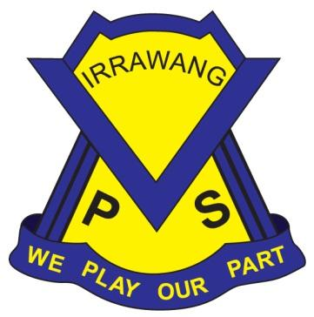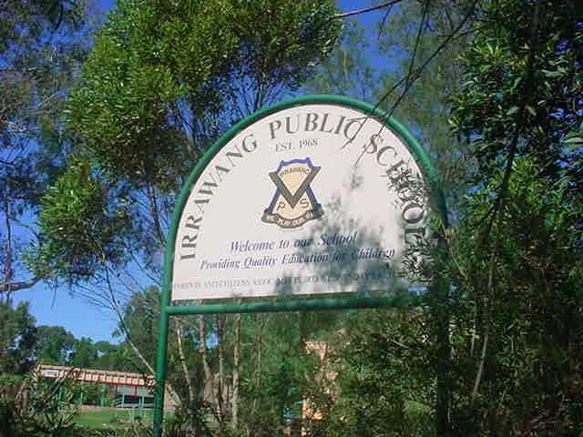

**IRRAWANG PUBLIC SCHOOL**

# Bus Transport 2022 Policy

**Last Review: Term 1, 2024 Next Review: Term 1, 2025**

**Principal:** Mrs Stacy Mathieson

In 2019 the NSW Transport Authority has clarified the requirements for student travel to and from school on NSW buses. The requirements are as follows:

**Students in Kindergarten- Year 2**

* They are a resident of NSW, or an overseas student eligible for free government education.
* Aged 4 years 6 months, or older.

No minimum walking distance criteria applies to these students.

**Students in Years 3-6**

* They are a resident of NSW, or an overseas student eligible for free government education.
* The straight line distance from their home address to school is more than 1.6 km.
* The walking distance from home to school is 2.3 km or further.

Primary school students who live too close to the school to be eligible for free travel may qualify for a [School Term Bus Pass](https://apps.transport.nsw.gov.au/ssts/#/termBusPass) which provides bus travel at a discounted price for the whole school term.

**Code of Conduct**

Students are also required to comply with the Code of Conduct which states:

**It is every student's responsibility to behave in a manner that ensures the safety and comfort of passengers and drivers.**

This includes:

##### *Behaviour on buses*

* Use appropriate language not offensive or racist language
* Fighting, spitting, feet on seats, throwing things in or from the bus is not permitted
* No eating or drinking (other than water) - unless for medical reasons or the bus operator gives written permission.
* Offer seats to adults including people with a disability, elderly or expectant mothers
* Do not push or shove other people
* Do not bully or harass other passengers or the driver
* Avoid attracting the attention of the driver except in the case of emergency
* Do not play music at such volume that it may distract the bus driver or other passengers.

##### *Safety on and near buses*

* Obey reasonable directions from the driver (e.g. where to sit or to remain in the bus)
* Remain in your seat - do not move around the bus unnecessarily
* If standing, remain behind the front passenger seat and keep a secure hand hold at all times
* Keep bags and other items clear of the aisle
* Do not allow any part of your body to protrude out of the bus at any time
* Wait for the bus in a quiet and orderly manner - including at bus interchanges
* Stand away from the roadside until the bus comes to a complete stop
* Allow other passengers to leave the bus before stepping onto the bus in a single line
* Wait until the bus stops before moving to get off the bus at your designated stop
* Cross the road where and when it's safe to do so, use crossings/traffic lights where available.

##### *Legal considerations on buses*

* Wear the seat belt properly adjusted and fastened, if one is available
* Obey the law that bans smoking on buses
* Ensure that buses are not vandalised - report any damage, e.g. graffiti and window etching, to the driver
* Do not interfere with bus property, equipment and signage
* Do not leave rubbish on the bus, or at bus stops or interchanges.

##### *Using bus passes:*

* Show travel passes or tickets to the driver on boarding and to Authorised Revenue Protection Officers, NSW
* Police Officers or bus company representative when requested
* Use the travel pass only for its intended purpose - do not lend your pass to other students or borrow a pass from them
* Swipe or 'dip' passes in ticket readers if available when boarding
* **If issued with a School Opal card, always tap on when boarding and tap off when leaving the bus.**

**Disobeying these rules may lead to the withdrawal of bus travel passes, banning students from travelling on buses and/or police prosecution and court action.**

Some of the buses now have seat belts - they’re brand new!

If there’s a seat belt on your seat make sure you wear it, the way you do while traveling in the car (Click Clack!)

Your bus driver’s job is to keep everyone safe. They need to pay attention to the road while driving – please wear your seat belt without having to be asked (Don’t forget!)

There are three seat belts on the seat, enough for students sitting by themselves or in twos or threes (Sharing is caring!)

Busways has just introduced new buses into our fleet which feature seat belts for passengers. Several vehicles will be deployed to schools soon and more will continue to be deployed over the next couple of years under the NSW government’s plan to have all school services in regional NSW operated by a seat belt-fitted fleet.

By law, all drivers and passengers must use the seat belts in any vehicle that is fitted with them.

Before our drivers operate a seat belt-fitted bus we will conduct training covering seatbelt regulations and their responsibilities.

While bus drivers will verbally remind students to fasten their seatbelts, it is the student’s responsibility to buckle themselves in. The driver’s responsibility is to transport students to and from school safely.

It would be a great assistance if you can help by talking to your children about wearing their seat belts on the bus without waiting to be asked. It is just like getting in the car – if there is a seat belt on their seat, they need to buckle up.

At Irrawang PS we have expectations that our students are Aussie 5 Superstars, Everywhere, Every time and to Everyone. This includes in their transitions to and from school. Please be aware that bus companies may be conducting checks of bus passes throughout the year, which may result in fines or removal of students from buses.

If you need support applying for bus passes or obtaining an Opal card, please consult the school office or the Transport NSW website.

**Bus Behaviour Discussion**

Dear Parent/Carer,

This is to inform you that the driver of the afternoon bus 1232 (Vogele St) has made a complaint about the behaviour he is witnessing. The school has addressed bus safety issues with the IPS student passengers, and we would like you to read the bus policy with your child, both sign as an acknowledgement and return to the school office.

Unacceptable behaviours that have been seen on the bus.

1. Yelling/creating excess noise and when asked to be quiet by the driver, students ignored him, making it difficult to concentrate.

2. Students leaving their seats and walking around the bus from seat to seat.

Should your child display/continue to display these behaviours, the bus company has the right to revoke your child’s bus pass and not allow them on due to continued unsafe behaviours.

We do not want this to happen to any of our IPS students so please discuss these issues with your child to ensure they are not displaying any of the above mentioned behaviours.

Kind Regards.

Stacy Mathieson

-------------------------------------------------------------------------------------------------------------------------------------

**Bus behaviour discussion slip – return to the front office**

**(please tick)**

* I have read and explained the expected bus travel expectations with my child.
* I understand my child can be withdrawn from bus travel by the bus company if behaviour on the bus is deemed unsafe or inappropriate.

Parent/Carer Name ____________________________ Signature ______________________

Student Name ____________________________ Class ______ Signature _______________