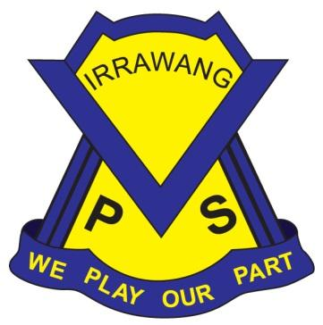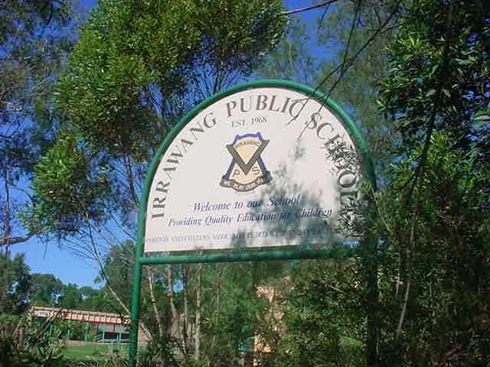

**IRRAWANG PUBLIC SCHOOL**

# Procedure for Complaints Handling

**Last Review: Term 2, 2024 Next Review: Term 2, 2025**

**Principal:** Mrs Stacy Mathieson

**attention Provides procedure and guidelines for handling complaints. While most complaints should be resolved informally with the relevant employee, there are provisions for the use of formal procedures depending on the nature and seriousness of the complaint.**

**Objectives - statement**

The NSW Department of Education (DoE) seek to resolve difficulties, grievances and complaints in a prompt, impartial and just manner.

**Audience and applicability**

* All DoE staff including TAFE NSW and Community and Migrant Education staff and operations.
* NSW DoE students, parents, care-givers and community members.

**Context**

The director-general and Minister have certain legislated responsibilities and functions which include ensuring educational establishments are efficient and effective. This policy is one tool to assist in meeting these requirements. The specific legislative provisions that apply are:

* Sections 6 and 7 of the Teaching Service Act 1980 – the director-general is responsible to the Minister for the general conduct and the efficient, effective and economical management of the functions and activities of the teaching service;
* Section 19 ofthe Education Act 1990 – the general functions of the Minister are set out and include to establish and supervise the operation of government schools; and
* Section 12 of the Technical and Further Education Commission Act 1990 *–* the functions of the TAFE Commission Board include to review and make recommendations to the Minister on, amongst other things, policies related to the technical and further education services provided by the TAFE Commission, and efficiency and effectiveness in relation to the operation and management of the technical and further educations services provided by the TAFE Commission.
* The NSW Office of the Director of Equal Opportunity in Public Employment Policy and Guidelines’ Dealing with Employee Work-related Concerns and Grievances states that the NSW Government requires public agencies to achieve and maintain workplaces that foster productive and harmonious working environments and where work related concerns or grievances are managed promptly, impartially and justly.
* The National Code of Good Practice for Responding to Complaints about Vocational and Education Training Quality – Australian Department of Education, Science and Training details the rights of education and training clients to the principles of fairness, accessibility, transparency, responsiveness, accountability and constructiveness.

Legislative provisions:

* Anti-Discrimination Act 1977
* Child Protection Legislation Amendment Act 2003
* Children and Young Persons (Care and Protection) Act 1998
* Commission for Children and Young People Act 1998
* Education Legislation Amendment (Staff) Act 2006
* Government and Related Appeals Tribunal Act 1980
* Occupational Health and Safety Act 2000
* Ombudsman Act 1974
* Protected Disclosures Act 1994
* Public Sector Employment and Management Act 2002

[**Document history and details**](https://detwww.det.nsw.edu.au/policies/general_man/complaints/resp_sugg/PD20020051_additional_i.shtml) **Responsibilities and delegations**

* The director-general of DoE and managing director of TAFE NSW, senior executives, senior officers, principals, managers and supervisors are responsible for the effective management of suggestions, complaints and allegations.
* All staff need to be aware of their responsibility to comply with the [DET Code of Conduct Procedures](https://www.det.nsw.edu.au/detresources/codeofconduct_REjgJwvdpO.pdf) and act in a manner which promotes a productive and harmonious working environment.
* Compliments/Complaints sheet available and accessible for all parents.

**Monitoring, evaluation and reporting requirements**

* All senior executives, senior officers, principals, managers and supervisors are responsible for monitoring and evaluating the operation of this policy within their area of responsibility.
* All senior executives, senior officers, principals, managers and supervisors will comply with all mandatory reporting requirements detailed in the guidelines to this policy.

**Contact**

Professional and Ethical standards (PES).  Information about [our role](https://education.nsw.gov.au/about-us/rights-and-accountability/department-of-education-code-of-conduct/welcome-to-employee-performance-and-conduct--epac-/about-epac) in relation to the management of conduct, performance and complaints and how to contact us.

**Guidelines for Handling Complaints/compliments/Suggestions:**

The guide for parents, carers and students provides useful information about the complaints process: education.nsw.gov.au/about-us/rights-and-accountability/complaints-compliments-and-suggestions/guide-for-parents-carers-and-students

APPENDIX A

Code of Conduct

https://education.nsw.gov.au/policy-library/policies/code-of-conduct-policy