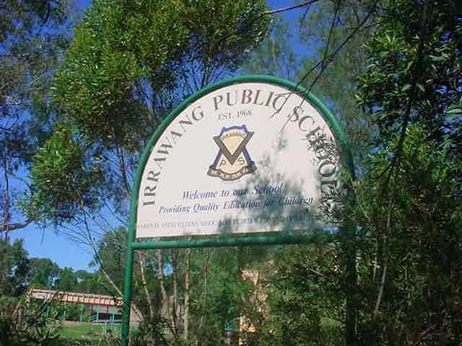

**IRRAWANG PUBLIC SCHOOL**

School Attendance Policy

**Last Review: Term 1, 2024 Next Review: Term 1, 2025**

**Principal:** Mrs Stacy Mathieson

This policy sets out the requirements for the attendance of students in NSW government schools.

[**Changes since previous update**](https://education.nsw.gov.au/policy-library/policies/pd-2005-0259#showhide02640018)

1. **Policy statement**
   1. **Section 22 of the**[**Education Act (1990)External link**](https://legislation.nsw.gov.au/view/html/inforce/current/act-1990-008)**states that it is the duty of the parent of a child of**[**compulsory school-age External link**](https://legislation.nsw.gov.au/view/html/inforce/current/act-1990-008#sec.21B) **to cause the child:**
      * **to be enrolled at, and to attend, a government school or a registered non-government school, or**
      * **to be registered for home schooling with the NSW Education Standards Authority (NESA) and to receive instruction in accordance with the conditions to which the registration is subject.**
   2. **All students who are enrolled at school, regardless of their age, are expected to attend that school whenever instruction is provided.**
   3. **Section 24 of the Act requires principals to maintain an attendance register (roll) in a form approved by the Minister. Attendance registers must be available for inspection during school hours by a Board Inspector or by any authorised person.**
2. **Audience and applicability**
   1. **This policy applies to all public schools, excluding preschools.**
3. **Context**
   1. **Regular attendance at school is essential to assist students to maximise their potential. Schools, in partnership with parents, are responsible for promoting the regular attendance of students.**
   2. **Encouraging regular attendance is a core school responsibility.**
   3. **This policy should be read in the context of the**[**Enrolment of Students in NSW Government Schools – A Summary and Consolidation of Policy**](https://education.nsw.gov.au/policy-library/policies/pd-2002-0006)**and the**[**General Enrolment Procedures (PDF 303.86KB)**](https://education.nsw.gov.au/content/dam/main-education/policy-library/associated-documents/pd-2002-0006-01.pdf)**.**
4. **Responsibilities and delegations**
   1. **Parents:**
      1. **It is the duty of the parent of a child of compulsory school-age to cause the child**
         * **to be enrolled at, and to attend, a government school or a registered non-government school, or**
         * **to be registered for home schooling with the NSW Education Standards Authority (NESA) and to receive instruction in accordance with the conditions to which the registration is subject.**
      2. **Parents are required to explain the absences of their children from school promptly and within seven days to the school. An explanation for absence must be provided to the school within 7 days of the first day of any period of absence.**
   2. **Principals:**
      1. **must provide clear information to students and parents regarding attendance requirements and the consequences of unsatisfactory attendance**
      2. **must ensure the school has effective measures in place to monitor and follow up student absences**
      3. **or their delegate will undertake all reasonable measures to contact parents promptly and within two school days of an absence being unexplained, if contact has not already been made. An absence is unexplained if parents have failed to provide an explanation to the school within 7 days**
      4. **are responsible for ensuring that attendance records are maintained in an approved format and are an accurate record of the attendance of students**
      5. **must ensure that for students with attendance concerns, the learning and support needs of those students are addressed in consultation with parents**
      6. **are responsible for ensuring that when frequent absences are explained as being due to illness that**
         * **consultation occurs with parents regarding the health care needs of the student**
         * **medical certificates are sought for the absences**
         * **where there are ongoing concerns, approval is sought from parents to contact the student's doctor so the school has all relevant information regarding the student's health care needs**
         * **strategies are developed to ensure regular attendance at school**
      7. **must ensure that school staff are provided with information on attendance requirements and their obligation to monitor and promote regular attendance at school**
      8. **must ensure that any matter relating to school attendance where safety, welfare or wellbeing concerns arise for a student**
         * **consideration is given to the requirements of the**[**protecting and supporting children and young people policy**](https://education.nsw.gov.au/policy-library/policies/pd-2002-0067)
         * **all required reports are made to the Community Services Child Protection Helpline or contact made with the Child Wellbeing unit (as required by the**[**Mandatory Reporter GuideExternal link**](http://www.keepthemsafe.nsw.gov.au/reporting_concerns/mandatory_reporter_guide)**)**
      9. **have the authority to**
         * **grant sick leave to students whose absences are satisfactorily explained as being due to illness**
         * **accept other explanations for absence and record the absence as 'L'**
         * **decline to accept an explanation for absence and record the absence as unjustified**
         * **grant an exemption from school attendance for periods totalling up to 100 days in a 12-month period for any one student provided certain conditions are met (see the**[**Exemption from School - Procedures**](https://education.nsw.gov.au/content/dam/main-education/policy-library/associated-documents/exempt_gui.pdf)**)**
         * **grant part-day exemptions from school for periods totalling up to 100 days in a 12-month period (see the**[**Exemption from School - Procedures**](https://education.nsw.gov.au/content/dam/main-education/policy-library/associated-documents/exempt_gui.pdf)**)**
         * **grant exemption from enrolment for students who have completed Year 9 and have the required approval to complete their education in special circumstances through an apprenticeship or traineeship (see the**[**Exemption from School - Procedures**](https://education.nsw.gov.au/content/dam/main-education/policy-library/associated-documents/exempt_gui.pdf)**)**
      10. **with support from attendance officers (home school liaison officers and Aboriginal student liaison officers), monitor the regular attendance of students and develop and implement strategies to support students with identified attendance issues.**
   3. **Directors, Educational Leadership:**
      1. **have the delegated authority to grant exemptions from attendance at school under Section 25 of the**[**Education Act (1990)External link**](https://legislation.nsw.gov.au/view/html/inforce/current/act-1990-008)**totalling up to 100 days in a 12-month period**
      2. **support schools to maintain accurate records of student attendance in a form approved by the Minister**
      3. **approve the participation of a student in an alternative school-based program, leading to full-time attendance, prior to part-day exemption from attendance at school being granted by the school principal (see the**[**Exemption from School - Procedures**](https://education.nsw.gov.au/content/dam/main-education/policy-library/associated-documents/exempt_gui.pdf)**).**
   4. **Executive Directors, School Performance:**
      1. **have the delegated authority to grant exemptions from attendance at school under Section 25 of the**[**Education Act (1990)External link**](https://legislation.nsw.gov.au/view/html/inforce/current/act-1990-008)**totalling more than 100 days in a 12-month period**
      2. **have the delegated authority to grant exemptions from enrolment at school under Section 25 of the**[**Education Act (1990)External link**](https://legislation.nsw.gov.au/view/html/inforce/current/act-1990-008)**, provided certain conditions are met.**
   5. **Director, Child Protection Services:**
      1. **has the delegated authority to grant exemptions from school attendance for any period of time, for students wishing to participate in employment in the entertainment industry or participation in elite arts or sporting events. Principals are also able to consider applications for exemption in these circumstances. Principals should contact the Director, Child Protection Services if advice is needed on compliance with employment regulation of the Children's Guardian or exemption is sought for participation in a large-scale production.**
5. **Monitoring and review**
   1. **The Director, Child Protection Services monitors the implementation of this policy, regularly reviews its contents to ensure relevance and accuracy, and updates it as needed.**
6. **Contact  
   Student Attendance and Educational Neglect Advisor  
   02 7814 2937**

*Completed by: Amy Phipps*

*Position: Assistant Principal*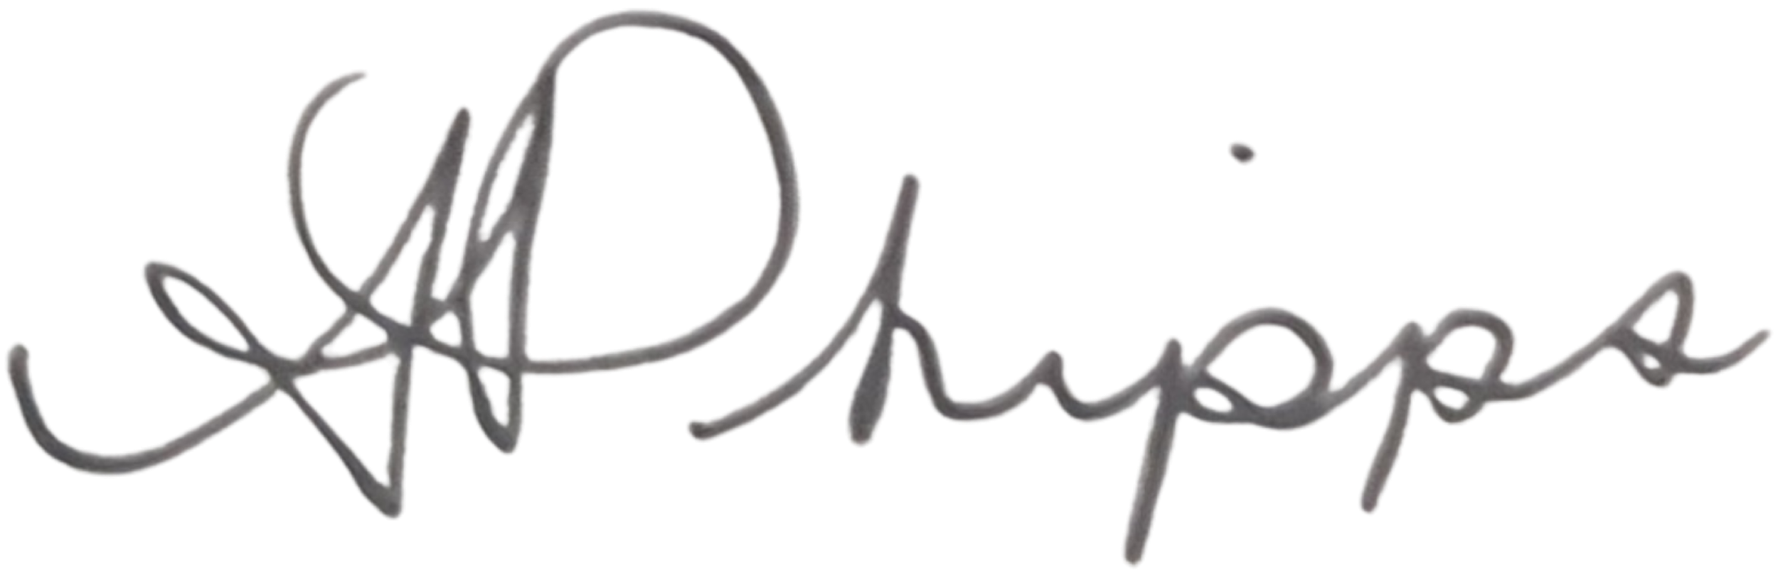

*Signature: Date: 8/02/2024*

*Principal name: Stacy Mathieson*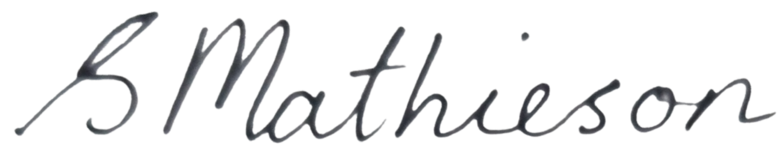

*Date: 8/02/2024*

*Signature: Date: 8/02/2024*

