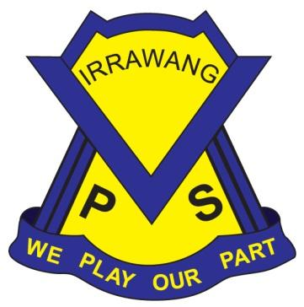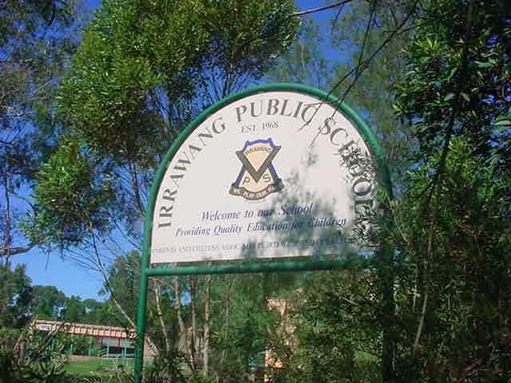

**IRRAWANG PUBLIC SCHOOL**

Student Health in NSW Public Schools:

A Summary and Consolidation of Procedures

**Last Review: Term 2, 2024 Next Review: Term 1, 2025**

**Principal:** Mrs Stacy Mathieson

**1. Objectives -** [**Policy Statement**](https://education.nsw.gov.au/policy-library/policies/student-health-in-nsw-public-schools-a-summary-and-consolidation-of-policy)

**1.1**

This requires schools to implement practices related to student health that comply with the NSW Work Health and Safety Act 2011 (WHS Act), Common Law obligations, and anti-discrimination and privacy legislation, and that demonstrate a commitment to collaboration with parents to support the wellbeing of students.

**1.2**

Schools assist students who have health support needs at school by means that include the provision of first aid (including emergency care), the provision of temporary care when students become unwell at school, the administration of prescribed medications and health care procedures, and the development of individual health care plans if required.

**1.3**

The health and safety of students is relevant to learning and is important at Irrawang Public School.

**1.4**

The present and future health of students can be enhanced by quality learning and positive experiences at Irrawang Public School.

**1.5**

All children and young people of legal school age are entitled to participate in education and training regardless of their health support needs.

**1.6**

Support for students on health issues must be provided in a way that does not discriminate unlawfully against any student.

**1.7**

Students benefit if they are provided with opportunities to develop the knowledge, skills and understandings relevant to managing their own health, taking into account what is reasonable and safe in an individual case. Schools are expected to support students to develop independence in managing their own health.

**1.8**

Schools rely on and value the cooperation of parents, medical practitioners, health services, other relevant agencies and local community resources to assist them to support the health of students.

**1.9**

Schools must assist with the administration of prescribed medication or health care procedures during school hours where this support cannot reasonably be undertaken by parents or others outside school hours. The non-emergency administration of prescribed medication and health care procedures by staff is performed on a voluntary basis.

**1.10**

The school's duty of care does not extend to administering medication and/or health care procedures to students who are able to administer this medication or carry out this procedure themselves. If, however, a student self-administers prescribed medication and/or health care procedures, the school has a duty to take reasonable steps to ensure that the self-administration is carried out safely.

**1.11 First Aid**

**1.11.1**

Schools are responsible for providing first aid at a local level and are required to implement department policy and procedures regarding first aid in schools.

Related information can be found at [First Aid](https://education.nsw.gov.au/inside-the-department/health-and-safety/emergency-planning-and-incident-response/first-aid)(intranet only).

**1.12 Care of students who become unwell at school**

**1.12.1**

Students who become unwell at school are best transferred to the care of parent/carer. The aim of care given at school to such students is to make them comfortable in the interim.

**1.12.2**

Each school needs to identify the staff members(s) who will care for students who are unwell and the procedures that are to be followed. This role can be carried out by staff members who have been asked by the principal to undertake these duties and who volunteer.

**1.12.3**

The principal is responsible for negotiating an appropriate arrangement for temporary care of students who are unwell at school. Learning and engagement staff from the local educational services office are available to assist.

**1.12.4**

In the special case of residential schools, arrangements for short term care for minor ailments may be undertaken as part of the school's provision in the residential facility.

**1.13 Administration of prescribed medications and health care procedures**

**1.13.1**

The administration of prescribed medications and health care procedures in schools can be carried out by staff members who volunteer to undertake these duties and who are trained. An administration of prescribed medications allowance is paid to school administrative and support staff members to carry out this role. A health care procedures allowance is paid to school learning support officers to carry out this role.

**1.13.2**

Where no staff member is prepared to volunteer for the non-emergency administration of prescribed medication or health care procedures and community resources cannot assist, the school must seek the advice of relevant learning and engagement staff from their educational service. The learning and engagement staff will, in some cases, seek the advice of the Disability Learning and Support Office or Student Engagement and Interagency Partnerships Office. An enrolment cannot be refused solely on the ground that no staff member is willing to assist.

See also [Individual students who need help with health issues.](https://education.nsw.gov.au/student-wellbeing/health-and-physical-care/health-care-procedures/individual-planning)

**1.14 Individual health care plans**

**1.14.1**

An individual health care plan must be developed for any student:

* diagnosed with severe asthma, type 1 diabetes, epilepsy or anaphylaxis and/or
* diagnosed as being at risk of an emergency and/or
* who requires the administration of health care procedures.

**1.14.2**

Principals have discretion about developing a written individual health care plan in other cases. Their decision will be guided by circumstances where the principal judges that a formal plan will assist in the school’s management of the support for the student.

**1.14.3**

Relevant staff must be consulted in the development of individual health care plans and in any cases where their assistance in administration of prescribed medication and/or health care procedures may be called upon. It is particularly important that they are consulted regarding students diagnosed with a condition that might require an emergency response. See also [Developing individual healthcare plans for students with more complex needs](https://education.nsw.gov.au/student-wellbeing/health-and-physical-care/health-care-procedures/individual-planning).

**2. Audience and applicability**

**2.1**

NSW Government schools, including preschools; parents/guardians/caregivers and the public.

**3. Context**

**3.1**

The NSW Department of Education is committed to meeting its obligations under the NSW Work Health and Safety Act 2011 and the Common Law, to keep students safe while they are at school. The department also seeks to provide opportunities for students to learn about and practise ways of adopting and maintaining a healthy, productive and active life through the student welfare policies and procedures of schools and through Personal Development, Health and Physical Education and other Key Learning Areas.

**3.2**

On specific issues related to student health and on public health priorities, the department is guided by advice from the [NSW Ministry of Health.](https://www.health.nsw.gov.au/Pages/default.aspx) Local health districts , including [Public Health Units](http://www.health.nsw.gov.au/Infectious/pages/phus.aspx) provide information and advice on local health issues.

**3.3**

Principals as workplace managers for WHS and injury management are accountable for safety within their school. Principals are required to recognise their obligations as workplace managers, ensure they implement department policies and procedures relating to their school's safety, and use resources available to manage safety issues in their school. See also [Health and Safety](https://education.nsw.gov.au/inside-the-department/health-and-safety/emergency-planning-and-incident-response/first-aid) (intranet).

**3.4 Legislation**

**3.4.1**

Under the [NSW Anti-Discrimination Act 1977](http://www.austlii.edu.au/au/legis/nsw/consol_act/aa1977204) and the [Commonwealth Disability Discrimination Act, 1992](http://www.austlii.edu.au/au/legis/cth/consol_act/dda1992264) it is unlawful to discriminate against students in relation to enrolment, or once enrolled, on the grounds of their disability. The definition of disability is very wide in both Acts and would include students who must take prescribed medication and/or who need health care procedures administered either on an ongoing or emergency basis.

**3.4.2**

Under the [NSW Work Health and Safety Act 2011 (WHS Act)](http://www.legislation.nsw.gov.au/maintop/view/inforce/act+10+2011+cd+0+N) the department must do everything reasonably practicable to ensure that students are not exposed to risks to their health or safety while they are at school. Under the Common Law, the department and its staff have a duty to take reasonable care to keep students safe.

**3.4.3**

Under the [NSW Privacy and Personal Information Protection Act 1998](http://www.austlii.edu.au/au/legis/nsw/consol_act/papipa1998464) the department and its staff have certain obligations regarding the collection, use and storage of personal information. Principals may obtain further information from Legal Services Privacy (Intranet only).

**3.4.4**

The [Health Records and Information Privacy Act 2002](http://www.austlii.edu.au/au/legis/nsw/consol_act/hraipa2002370) ("The Health Privacy Act") protects the health information of individuals in NSW.

**4. Responsibilities and delegations**

**4.1 Principals:**

**4.1.1**

It is the responsibility of the principal to implement policy and procedures to ensure that systems are in place to protect the health and safety of all students when they are at school or involved in school activities.

**4.1.2**

Principals need to develop and document local procedures to support student health which reflect department policy and incorporate local needs, including:

* [first aid](https://education.nsw.gov.au/inside-the-department/health-and-safety/emergency-planning-and-incident-response/first-aid) (staff only)
* temporary care of students who become unwell at schools (see section 1.12)
* the administration of [prescribed medications](https://education.nsw.gov.au/student-wellbeing/health-and-physical-care/health-care-procedures) and [health care procedures](https://education.nsw.gov.au/student-wellbeing/health-and-physical-care/health-care-procedures) (see section 1.13 and related website information)
* [individual health care plans](https://education.nsw.gov.au/student-wellbeing/health-and-physical-care/health-care-procedures/individual-planning) (see section 1.14 and related website information)
* [immunisation documentation requirements](https://education.nsw.gov.au/student-wellbeing/health-and-physical-care/immunisation) (see related website information)
* supply and storage of medication
* [provision of emergency care](https://education.nsw.gov.au/student-wellbeing/health-and-physical-care/health-care-procedures) (see related website information at staff training -and see [Training and Policies Requiring Regular Review](https://esafety.det.nsw.edu.au/main.aspx)).

**4.2 All school staff:**

**4.2.1**

It is the responsibility of school staff to:

* take reasonable measures to protect students against risk of injury or harm which should reasonably have been foreseen.
* take reasonable care for the health and safety of all persons in the workplace and to cooperate with the employer to ensure that health and safety of all in the workplace, including assisting in an emergency.
* where staff do not have first aid qualifications, provide assistance to ensure that a student receives medical attention including first aid.

**4.3. Particular staff members:**

**4.3.1**

It is the responsibility of the person(s) who volunteers and is (are) trained in the administration of medications to administer prescribed medications in accordance with department policy and procedures.

**4.3.2**

It is the responsibility of the person(s) who volunteers and is (are) trained to perform health care procedures to administer health care procedures in accordance with department policy and procedures.

**4.3.3**

It is the responsibility of the person(s) who volunteers and is (are) trained in the administration of first aid to administer first aid in accordance with department policy and procedures.

**4.4. Expectations of parents/guardians/caregivers:**

**4.4.1**

Parents are expected to:

* cooperate with the school on student health matters.
* inform the school of the health needs of the child at enrolment or when health conditions develop or change.
* liaise with the child's medical practitioner about the implications of any health condition for their schooling and convey advice and information from the medical practitioner to the school.
* if required, provide prescribed medication and 'consumables' for administration by the school in a timely way and as agreed with the principal.
* where relevant, collaborate with the school in planning to support the child's health needs at school including updating information and reviewing plans. Relevant information on the role of parents can be found on the department's [student health section of the public school’s website](https://education.nsw.gov.au/public-schools/practical-help-for-parents-and-carers/quick-guide-for-parents).

**4.5 Expectations of students:**

**4.5.1**

Students are expected to:

* contribute to the provision of a healthy and safe school environment.
* ensure that medication is taken for the purpose for which it is intended by the person for whom it is intended.
* cooperate with staff in managing their health.
* as relevant to the individual, develop the understandings and skills needed to progressively manage their own health.

**5. Monitoring, evaluation and reporting requirements**

**5.1**

The NSW Work Health and Safety Act 2011 (WHS Act) requires the reporting of certain work-related incidents within given timeframes. Depending on the type of incident, WorkCover may need to be notified.

**5.2**

Incidents and injuries are reported in accordance with the [Incident Reporting Policy](https://education.nsw.gov.au/policy-library/policies/incident-reporting-policy).(intranet).

**5.3**

Principals will ensure that individual health care plans are reviewed at least annually.

**5.4**

Directors, Public Schools will monitor the local implementation of this policy and report to their Executive Director, Public Schools.

**5.5**

The Executive Director, Learning and Engagement will monitor the state-wide implementation of this policy.

**6. Contact**

Leader, Health and Wellbeing, 9244 5321.